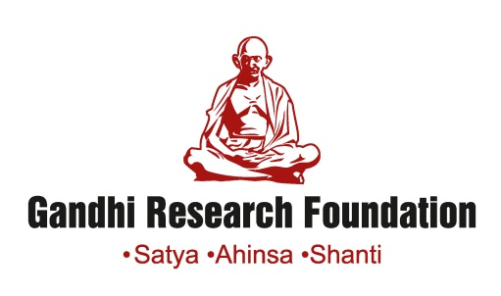
Gandhi Teerth, Jain Hills, Jalgaon, Maharashtra
http://www.gandhifoundation.net/

CALL FOR STUDENT INTERNS

Are you interested in knowing what goes on behind the screens of history writing? Then, please join the Archival Project at the Gandhi Research Foundation (GRF) to learn more. Here you can be part of an exciting program and make history come alive!
The GRF’s archival collection comprises extensive holdings of original manuscripts by Mahatma Gandhi, as well as correspondence with his close associates and other unique unpublished documents stretching over a period of almost a century. We invite applications from dynamic young students to assist the Digitization Department at the GRF in organizing these documents chronologically, alphabetically and thematically.
The GRF Internship Objectives:
- To create one of India’s first and only digital archives of manuscripts by and on Mahatma Gandhi;
- To present the digital archive as a tool of professional and new academic engagement with Gandhian studies;
- To provide greater accessibility of primary sources to researchers working on Gandhiji;
- To enable student interns, through exposure to archival methods, to become discerning contributors towards making history.

Qualification and Skills:
-Undergraduate students in their 2nd/3rd year of study and/or 1st year MA students;
- Comprehension and competency in English (mandatory) as well as Hindi or Gujarati;
- Computer literacy and a knowledge of MS Word and MS Excel.

Stipend: Rs 5,000-10,000 @ month (depending on the intern’s performance);
Duration: 4-6 weeks (extension possible), 8 hours @day (Sunday or Monday off), free vegetarian canteen meals, free accommodation on campus.

Internship Application: ongoing

To APPLY, please submit your application on the following link:
https://docs.google.com/forms/d/1asAbkmUqGOX1aGX6SD8EqaU3Og4eFS-2bdZO0yOmbME/edit

For further details, please contact: info@gandhifoundation.net and prof.dharampal.gita@gandhifoundation.net or phone: +91 9112203468 (Prof. Gita Dharampal, GRF Research Dean).

